**OBJECTIVE QUESTIONS**

1. **List the different dtypes of columns in table “ball_by_ball” (using information schema)**

To determine the different datatypes in table ball_by_ball is by using the below query. This query will return the column names and their corresponding data types from the ball_by_ball table, giving the required output in a simple tabular format.

**Query:**

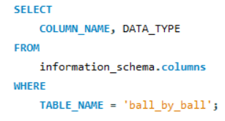

**Output:**

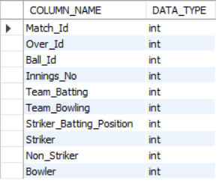

1. **What is the total number of runs scored in 1st season by RCB (bonus: also include the extra runs using the extra runs table)**

To determine the total runs scored by Royal Challengers Bangalore (RCB) in the inaugural IPL season, including extra runs, the following tables are essential:

**Required Tables:**

* **matches:** Holds details of each match, including the teams involved and the season.
* **team:** Contains team information like names and IDs.
* **ball_by_ball:** Captures data for each ball bowled, specifying the batting team.
* **batsman_scored:** Tracks runs made by batsmen on individual deliveries.  
  **extra_runs:** Logs additional runs such as wides and no-balls.

**Query Strategy:**

* **Match Filtering:** Identify matches where RCB (Team_Id = 2) participated during the first IPL season (Season_Id = 1).
* **Table Joins:** Join the necessary tables to link matches, ball events, runs scored, and extra runs.
* **Run Summation:** Calculate the total runs by summing the runs scored by RCB’s batsmen along with extra runs.
* **Final Output:** Display the total runs scored by RCB in the first season.

**Query**:

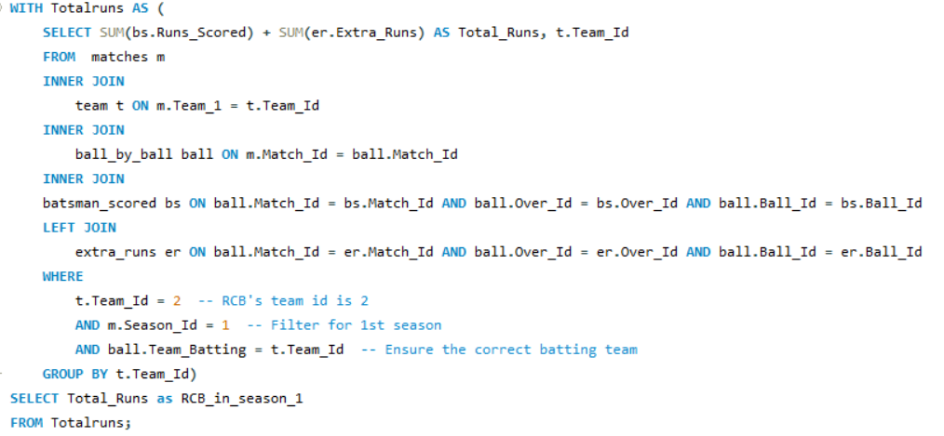

**Output:**

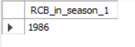

The total number of runs scored by Royal Challengers Bangalore (RCB) in the first IPL season, including extra runs, is **1986**.

1. **How many players were more than age of 25 during season 2?**

To determine the number of players who were aged more than 25 during season 2

**Required Tables:**

* player: Stores player information, including their date of birth (DOB).
* player_match: Links players to matches they participated in.
* matches: Contains match details, including the match date.
* season: Stores season-related information, including season IDs.

**Query Strategy:**

1. **Match Selection:** Focuses on matches that occurred during Season 2 by filtering Season_Id = 2.
2. **Join Tables:** Joins the player, player_match, matches, and season tables to establish the relationship between players and matches during the season.
3. **Age Calculation:** Uses the TIMESTAMPDIFF() function to calculate the player’s age at the time of each match.
4. **Age Filter:** Filters players whose age was greater than 25 during Season 2.
5. **Count Distinct Players:** Ensures each player is counted once, even if they played multiple matches.

**Query:**

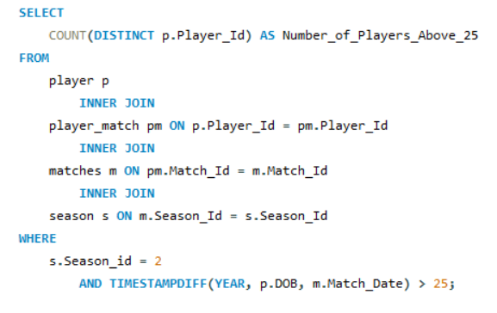

**Output**

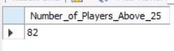

**Answer:**

The number of players over the age of 25 during Season 2 is **82**.

1. **How many matches did RCB win in season 1?**

To determine the number of matches won by Royal Challengers Bangalore (RCB) in the first season.

**Required Tables:**

* **matches:** Contains match details, including the winning team.
* **season:** Stores information about different seasons of the tournament.
* **team:** Provides team names and IDs.

**Query Strategy:**

* **Match Filtering:** Focus on matches that took place in Season 1 (Season_Id = 1).
* **Join Tables:** Join the matches, season, and team tables to link matches with the teams and season.
* **Team Filter:** Filter matches where Royal Challengers Bangalore (RCB) was the winning team (Team_Name = 'Royal Challengers Bangalore').
* **Count Wins:** Count the total number of matches RCB won in the first season.

**Query:**

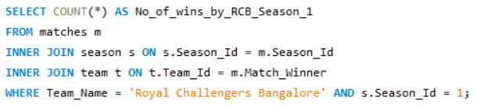

**Output:**



The number of matches RCB won in Season 1 is 4.

1. **List top 10 players according to their strike rate in last 4 seasons**

To identify the top 10 players based on their strike rate over the last four seasons, the following tables are required:**Required Tables:**

* **player:** Contains player details, including their names and IDs.
* **ball_by_ball:** Tracks each ball bowled, including the batsman on strike.
* **matches:** Contains match details, linking players to matches.
* **batsman_scored:** Records runs scored by batsmen on each ball.
* **season:** Stores information about different seasons of the tournament.

**Query Strategy:**

* **Strike Rate Calculation:** Calculate the strike rate for each player as the total runs scored divided by the total balls faced, multiplied by 100.
* **Match Filtering:** Focus on matches from the last four seasons (Season IDs 6, 7, 8, and 9).
* **Join Tables:** Join the necessary tables to link players with their performances in matches.
* **Row Ranking:** Rank players based on their calculated strike rate in descending order.
* **Select Top Players**: Retrieve the top 10 players based on their strike rates.

**Query:**

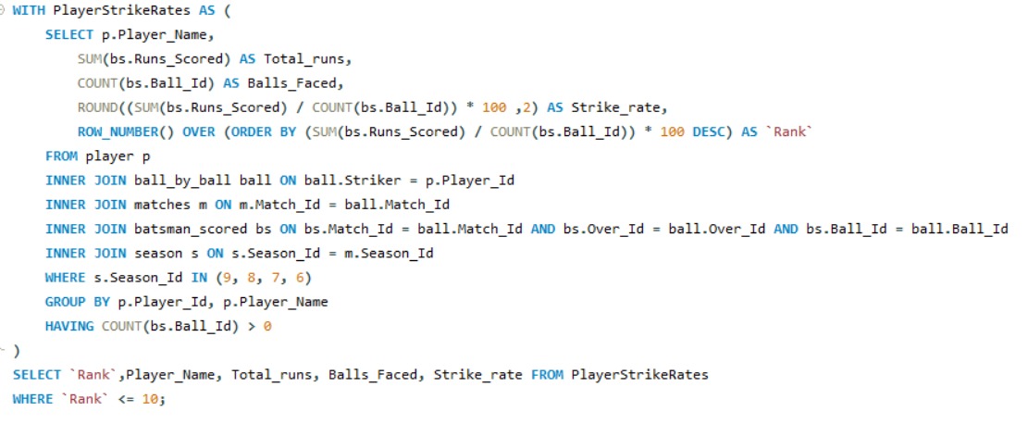

The query will return the names, total runs, balls faced, and strike rates of the top 10 players from the last four seasons based on their performance.

**Output:**

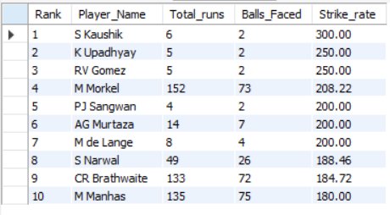

To ensure the data is more reliable and focused on consistent performers, we will add a condition to the query that filters out players who have faced fewer than 250 balls. This adjustment will help us identify batsmen who have demonstrated a strong strike rate while also facing a significant number of deliveries, indicating their ability to perform consistently across matches.

**Assumptions on selecting 250 balls benchmark:**

* **Sufficient Sample Size**:

Players who have faced at least 250 balls are likely to have batted in multiple games, providing a meaningful sample size for evaluating their batting abilities, such as strike rate, consistency, and adaptability.

* **Consistency in Performance**:

Facing 250 balls indicates that the player has had enough time at the crease to demonstrate consistent performance across different match conditions. This helps filter out "one-off" high scores and allows a fair assessment of reliable contributors.

* **Reducing the Influence of Limited Appearances**:

This benchmark eliminates players who may have performed well in only a handful of games but haven't sustained that level over time, making the data more relevant for strategic planning and team selection.

* **Better Insights into Strike Rate**:

For batsmen, strike rate is an essential metric, especially in formats like T20. The 250-ball threshold ensures that the calculated strike rate is not skewed by a small number of high-impact innings, offering a better picture of their scoring ability across matches.

* **Reflecting Team Expectations**:

Players expected to contribute meaningfully in batting positions should face a decent number of balls. This threshold aligns with the team’s expectations from reliable top or middle-order batsmen and ensures they can handle pressure over time.

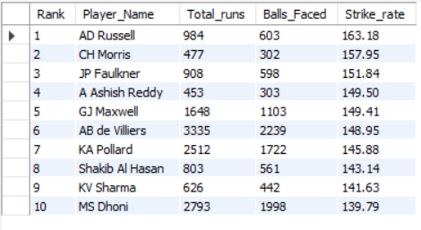

This focus on consistency will provide a clearer picture of players who excel in both scoring and endurance throughout the matches.

1. **What are the average runs scored by each batsman considering all the seasons?**

To calculate the average runs scored by each batsman across all seasons, including total runs and innings played.

**Required Tables:**

* **player:** Contains player details including Player_ID and Player_Name.
* **ball_by_ball:** Tracks the balls faced by each player during the match.
* **batsman_scored:** Records runs scored by batsmen for each ball in the match.

**Query Strategy:**

1. **Summing Total Runs:** For each batsman, the total runs scored are summed across all matches.
2. **Innings Count:** Distinct matches are counted as innings to represent the number of innings each batsman played.
3. **Average Calculation:** The average runs are calculated by dividing the total runs scored by the number of innings played for each batsman.
4. **Ranking:** The query ranks batsmen based on their calculated average runs, from highest to lowest.
5. **Order Results:** The query returns batsman names, their average runs, and the corresponding rank.

**Query:**

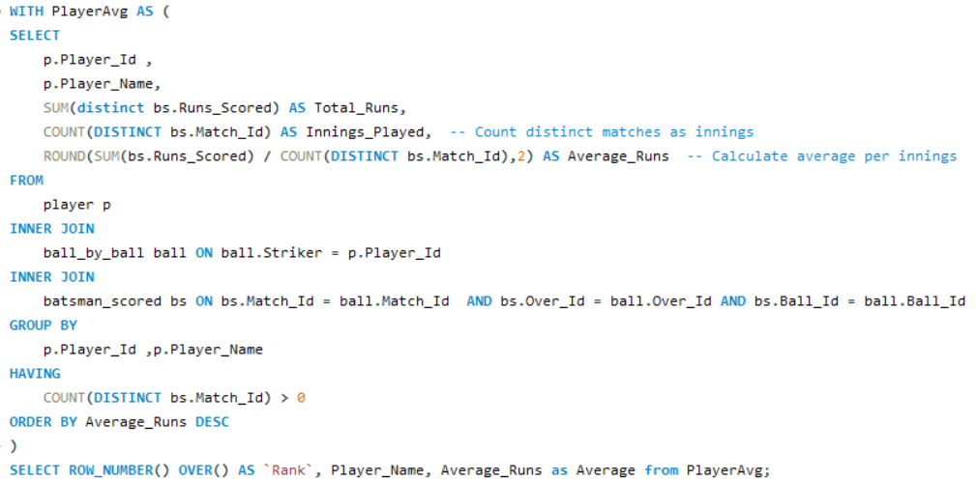

**Output:**

This query will return the average runs scored by each batsman across all seasons, ranked in descending order. The output will show**Rank:** The rank based on average runs.**Player_Name:** The name of the batsman.**Average:** The calculated average runs per innings for each player.

The query will return the average runs for all players, making it challenging to include the full output in a report. Therefore, to make the data more concise and relevant I have attached only 10 records of the result.

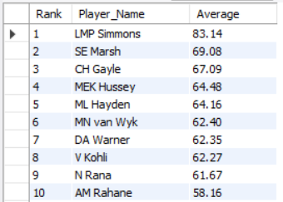

1. **What are the average wickets taken by each bowler considering all the seasons?**

The query calculates the average number of wickets taken per match for each bowler across all IPL seasons.**Required Tables:**

* **player:** Contains details about each player, including their ID and name.
* **ball_by_ball:** Tracks every ball bowled, including the bowler for each delivery.
* **wicket_taken:** Stores information about each wicket, including which ball, over, and match the wicket was taken in.

**Query Strategy:**

1. **Aggregating Wickets:** For each bowler, calculate the total number of wickets by counting the number of times a wicket was taken (wt.Player_Out).
2. **Calculating Matches Played:** Count the distinct matches the bowler played in, using DISTINCT on ball.Match_Id.
3. **Average Wickets Calculation:** Divide the total wickets by the number of matches played to get the average wickets per match for each bowler.
4. **Ranking:** Rank the bowlers based on their average wickets in descending order.

**Query:**

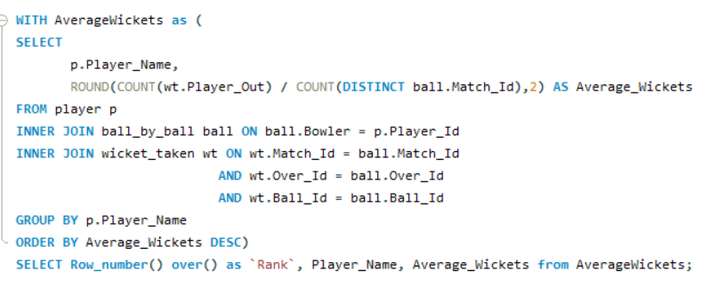

**Output:**

This query will return the average wickets taken by each bowler across all seasons, ranked in descending order. The output will display the following

* + - **Rank:** The rank based on average wickets per match.
    - **Player_Name:** The name of the bowler.
    - **Average_Wickets:** The calculated average number of wickets taken per match for each player.

Since the query will return the average wickets for all players, it may be too extensive to include the entire output in a report. To make the data more concise and relevant, only the top 10 records are attached for the result.

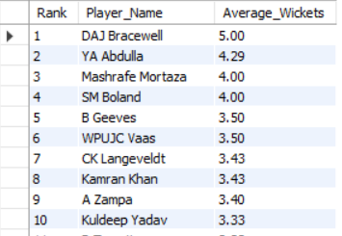

1. **List all the players who have average runs scored greater than overall average and who have taken wickets greater than overall average**

This query aims to identify players who exceed both the average runs scored and the average wickets taken across all players in the dataset. It calculates individual averages and then compares them to the overall averages, providing a list of top-performing players in both batting and bowling.

**Required Tables:**

* **player:** Contains player information such as Player_Id and Player_Name.
* **ball_by_ball:** Tracks each ball bowled and the corresponding players involved.
* **batsman_scored:** Records runs scored by batsmen for each ball
* **wicket_taken:** Captures wicket information for each player in the match.

**Query Strategy:**

* **Aggregating Runs:** Calculate the average runs per match for each batsman by summing the runs scored and dividing by the distinct number of matches played.
* **Aggregating Wickets:** For each bowler, calculate the total number of wickets by counting the occurrences of wt.Player_Out, which indicates a wicket taken.
* **Calculating Matches Played:** Count the distinct matches each bowler participated in by using DISTINCT on ball.Match_Id.
* **Average Wickets Calculation:** Divide the total wickets taken by the number of matches played to derive the average wickets per match for each bowler.
* **Overall Averages Calculation:** Compute the overall averages for both runs and wickets across all players to serve as a benchmark for comparison.
* **Filtering Players:** Select players whose average runs scored exceeds the overall average runs and whose total wickets taken surpass the overall average wickets.
* **Ranking:** Rank the players based on their average runs and total wickets in descending order for easy identification of top performers.

**Query:**

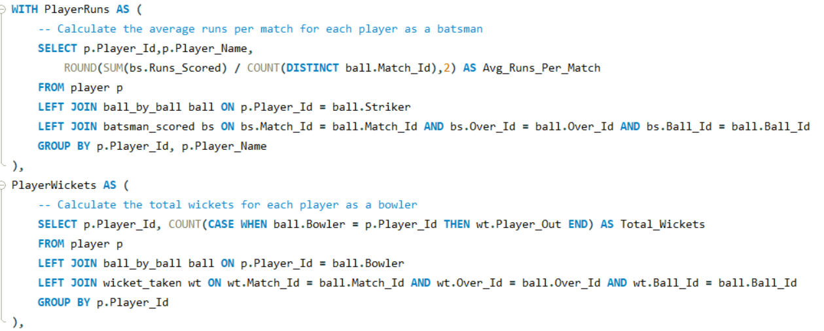

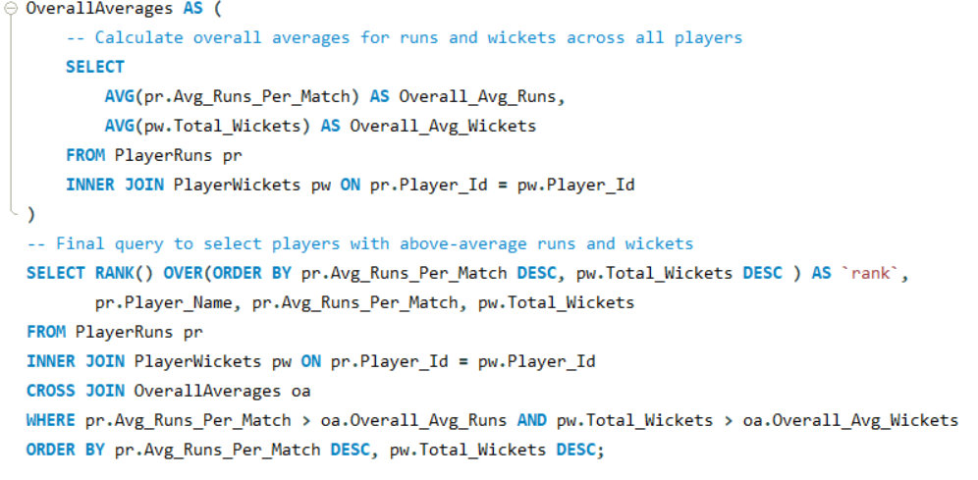

**Output:**

The output will display the following columns:

* **Rank:** The rank of the player based on average runs scored and wickets taken.
* **Player_Name:** The name of the player.
* **Avg_Runs_Per_Match:** The average runs scored by the player per match.

**Total_Wickets:** The total number of wickets taken by the player.

Since the query will return the average runs and Total wickets for all players, it may be too extensive to include the entire output in a report. To make the data more concise and relevant, only the top 10 records are attached for the result.

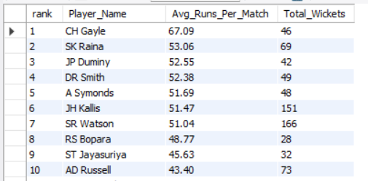

1. **Create a table rcb_record table that shows wins and losses of RCB in an individual venue.**

**Required Tables:**

* **matches**: Stores match details, including teams, venue, and match winner.
* **team**: Provides team names and IDs.
* **venue**: Contains venue details, such as venue names and IDs.

**Query Strategy:**

1. **Filter for RCB Matches**: Select matches where either Team_1 or Team_2 is "Royal Challengers Bangalore" by joining with the team table.
2. **Aggregate Matches by Venue**: For each venue, count the total number of matches played by RCB.
3. **Calculate Wins and Losses**:
   * **Wins**: Count matches where the winning team is RCB.
   * **Losses**: Count matches where RCB participated but did not win.
4. **Calculate No Result (NR)**: Subtract the sum of wins and losses from total matches to determine the number of "no result" matches for RCB at each venue.
5. **Output**: Display the venue name, total matches, wins, losses, and no result (NR) matches.

**Query:**

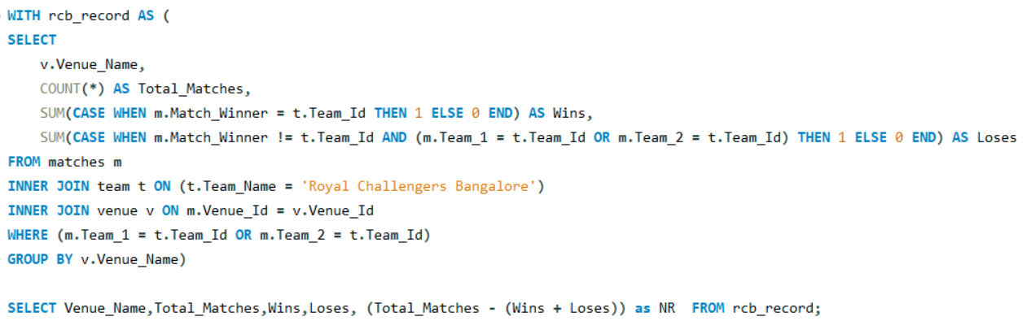

**Output:**

The query will output the following columns:

* **Venue_Name**: The name of each venue where RCB has played.
* **Total_Matches**: The total number of matches RCB played at each venue.
* **Wins**: The number of matches won by RCB at each venue.
* **Loses**: The number of matches lost by RCB at each venue.
* **NR**: The count of "no result" matches for RCB at each venue, calculated as matches that were neither wins nor losses.

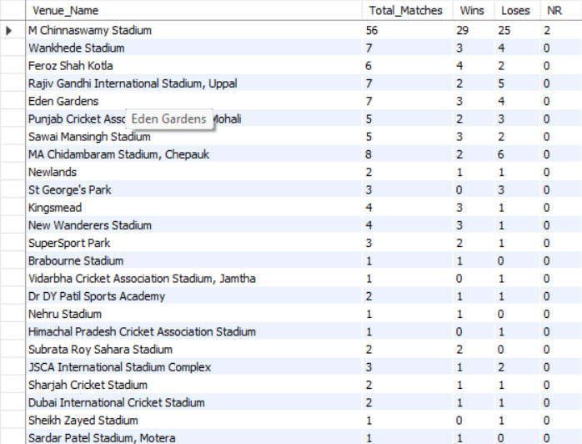

1. **What is the impact of bowling style on wickets taken.**

**Required Tables:**

* **player**: Contains details of players, including their bowling skills.
* **bowling_style**: Provides the types of bowling skills, with a unique ID for each style.
* **ball_by_ball**: Contains data on each ball bowled in a match, including the bowler's ID.
* **wicket_taken**: Records details of each wicket taken, including the type of dismissal and the bowler involved.

**Query Strategy:**

1. **Filter for Bowler Wickets**: Join the player table with bowling_style to access each bowler's skill.
2. **Exclude Run-Outs**: Restrict the data to dismissals where Kind_Out is not equal to 3, which represents run-outs.
3. **Count Wickets per Bowling Style**:
   * Count the total number of wickets taken for each bowling skill by joining the ball_by_ball table with the wicket_taken table.
4. **Order by Wickets Taken**: Sort the results in descending order to highlight the most effective bowling styles.

**Query:**

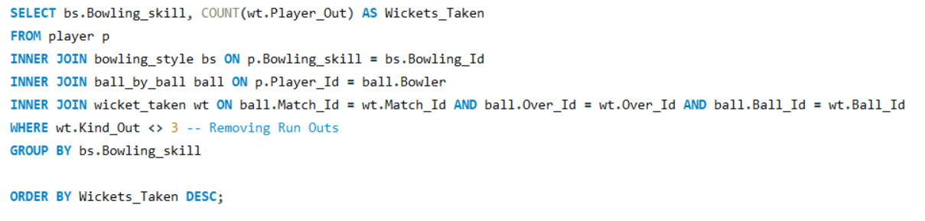

**Output:**

The query will return the following columns:

* **Bowling_skill**: The type of bowling style (e.g., spin, fast).
* **Wickets_Taken**: The total number of wickets taken by players with each bowling style, ranked in descending order.

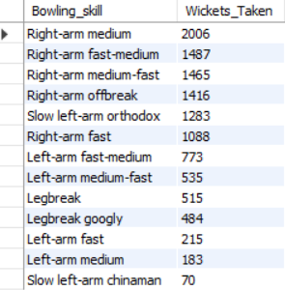

1. **Write the sql query to provide a status of whether the performance of the team better than the previous year performance on the basis of number of runs scored by the team in the season and number of wickets taken**

**Required Tables**

* **team**: Contains information about each team, including their IDs and names.
* **player_match**: Links players to the matches they participated in and the team they represented.
* **matches**: Contains match data, including match IDs and team participants.
* **batsman_scored**: Holds data about runs scored by each batsman in a given match.
* **wicket_taken**: Records the wickets taken, including the players who got out.
* **season**: Contains data on different IPL seasons, including season IDs and years.

**Query Strategy:**

1. **Team Performance Calculation:** Created a Common Table Expression (CTE) named TeamPerformance to summarize each team's performance per season. For each team and season, calculated the total runs scored and total wickets taken.
   * Joined team, player_match, and matches tables to gather each team's seasonal match data.
   * Aggregated the runs scored using a subquery on batsman_scored, totalling up the runs per match and joining it with the matches table.
   * Counted total wickets using a subquery on wicket_taken, excluding cases where no player was out.
2. **Comparing Year-on-Year Performance:**
   * Using the TeamPerformance CTE, matched each team's performance data from one year with the subsequent year using a self-join, linking records by Team_Name and consecutive Season_Year.
   * For each year-to-year comparison, identified whether the team’s performance was "Better," "Same," "Mixed," or "Worse" based on both runs scored and wickets taken.
3. **Performance Status Evaluation:**
   * Established a CASE statement to set the Performance_Status field, defining performance improvements by comparing runs and wickets across years. The conditions are:
     + "Better" if both runs and wickets increased.
     + "Same" if both values stayed the same.
     + "Mixed" if only one value increased.
     + "Worse" if both values decreased.
   * Sorted the output by Team_Name and Season_Year for clear chronological reporting.

**Query:**

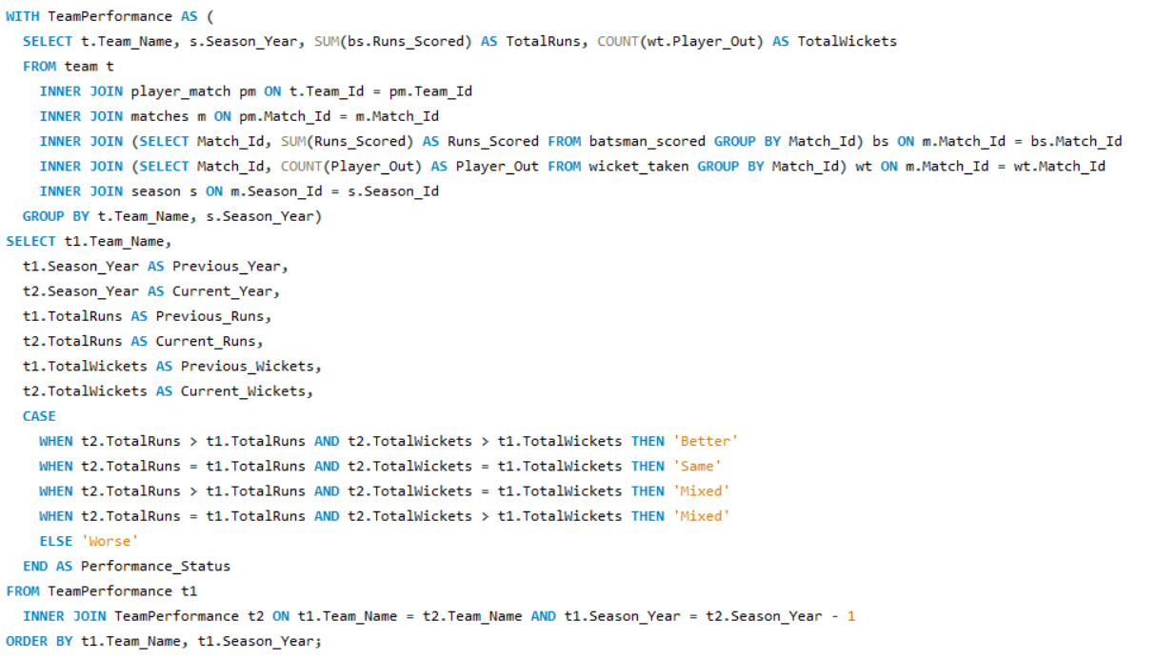

**Output:**

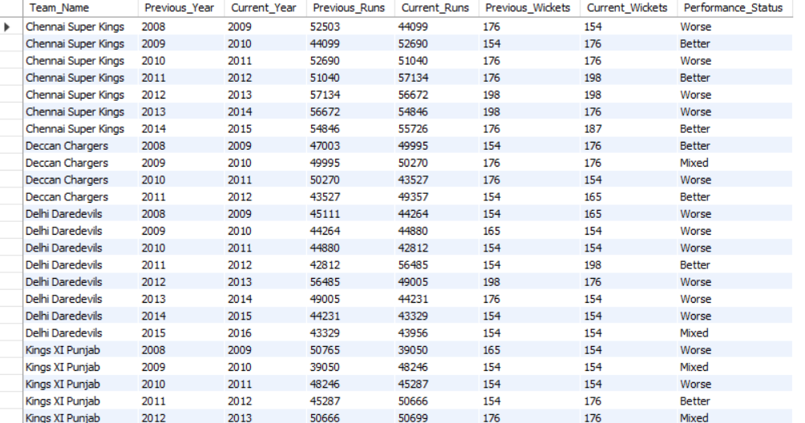

The query will return:

* **Previous_Year**: The year of the previous season.
* **Current_Year**: The year of the current season.
* **Previous_Runs**: The total runs scored by the team in the previous season.
* **Current_Runs**: The total runs scored by the team in the current season.
* **Previous_Wickets**: The total wickets taken by the team in the previous season.
* **Current_Wickets**: The total wickets taken by the team in the current season.
* **Performance_Status**: The assessment of performance as "Better," "Same," "Mixed," or "Worse" based on the comparison of runs and wickets across seasons.

1. **Can you derive more KPIs for the team strategy if possible?**

Here are some key performance indicators (KPIs) that can be derived for the Royal Challengers Bangalore (RCB) team strategy:

**1. Top Order Stability**

* **Average Top Order Contribution**: Measures the average percentage contribution of top-order batsmen (positions 1-3) to the team's total runs in matches. A high percentage indicates strong top-order performance, contributing significantly to the team's overall score.

**2. Batting Performances**

* **Average Powerplay Runs**: The average runs scored by RCB during the powerplay overs (1-6). This indicates how effectively the team capitalizes on the initial overs.
* **Average Wickets Lost in Powerplay**: The average number of wickets lost during the powerplay, which highlights the stability and risk taken by the batting order early in the innings.
* **Average Death Overs Strike Rate**: The average strike rate during the death overs (17-20). This reflects how aggressively the team scores when the game is on the line.
* **Average Boundaries Per Match**: The average number of boundaries (fours and sixes) scored per match, indicating the team's ability to score quickly and keep the run rate high.
* **Boundary Per Ball**: This KPI measures the frequency of boundaries relative to total balls faced, providing insight into the batting aggression and efficiency.

**3. Bowling Performances**

* **Average Powerplay Economy**: The average runs conceded by RCB during the powerplay overs. A low economy rate here indicates effective bowling during the crucial early overs.
* **Average Middle Overs Economy**: The average runs conceded during the middle overs (7-15), which can show how well the team contains runs in the transitional phase of the game.
* **Average Death Overs Economy**: The average runs conceded in the death overs, which is crucial for understanding how well the bowlers perform under pressure.

**Strategic Insights:**

* **Batting Depth**: Analyse the contribution of top-order batsmen versus lower-order batsmen. If the top order consistently scores well, RCB might rely on them more heavily.
* **Powerplay Strategy**: High powerplay runs with low wickets lost suggest an aggressive approach that could be emphasized.
* **Aggression in Death Overs**: High strike rates in death overs with a reasonable economy could indicate a strategy focused on finishing strong, especially if they can also contain runs during earlier phases.
* **Bowling Consistency**: Economical bowling across all phases is critical; if there are spikes in the economy in middle or death overs, it could necessitate tactical adjustments.

By combining insights from these KPIs, RCB can make informed decisions on both batting and bowling strategies, tailoring their approach to maximize strengths and address weaknesses as needed throughout the season.

**Required Tables:**

1. **matches**: Stores data on each match, including match ID and other match-specific details.
2. **ball_by_ball**: Contains ball-level data for each match, including match ID, over ID, ball ID, batsman, bowler, and the runs scored.
3. **batsman_scored**: Details runs scored by each batsman for a specific ball, with fields like match ID, over ID, ball ID, and runs scored.
4. **team**: Stores team details, including team name and ID.
5. **wicket_taken**: Contains data on wickets taken, including match ID, over ID, ball ID, and player out.

**Query Strategy:**

**KPI 1: Top Order Stability**

1. Summarize runs scored by the top three batsmen in each match.
2. Calculate the percentage contribution of these top-order runs to the total runs in each match for Royal Challengers Bangalore.
3. Aggregate the data to get the average top-order contribution across all matches.

**KPI 2: Powerplay Performance**

1. Calculate runs scored and wickets lost by RCB in the Powerplay overs (1–6) for each match.
2. Calculate the average runs and wickets lost in this phase across multiple matches.

**KPI 3: Death Overs Strike Rate**

1. Calculate the total runs scored and balls faced by RCB in the Death Overs (17–20).
2. Compute the strike rate by dividing runs by balls faced and averaging it across matches.

**KPI 4: Boundary-Hitting Ability**

1. Count the total number of boundaries (4s and 6s) hit by RCB in each match and the total number of balls faced.
2. Calculate the boundary frequency as the average number of balls per boundary hit across matches.

**KPI 5:** **Bowling Economy Rate by Phase**

1. For each match, calculate the total runs conceded and overs bowled by RCB’s bowlers in three phases: Powerplay (1–6), Middle Overs (7–15), and Death Overs (16–20).
2. Calculate the economy rate for each phase by dividing runs by overs bowled.
3. Compute the average economy rate for each phase across matches.

**Query 1: Top Order Stability**

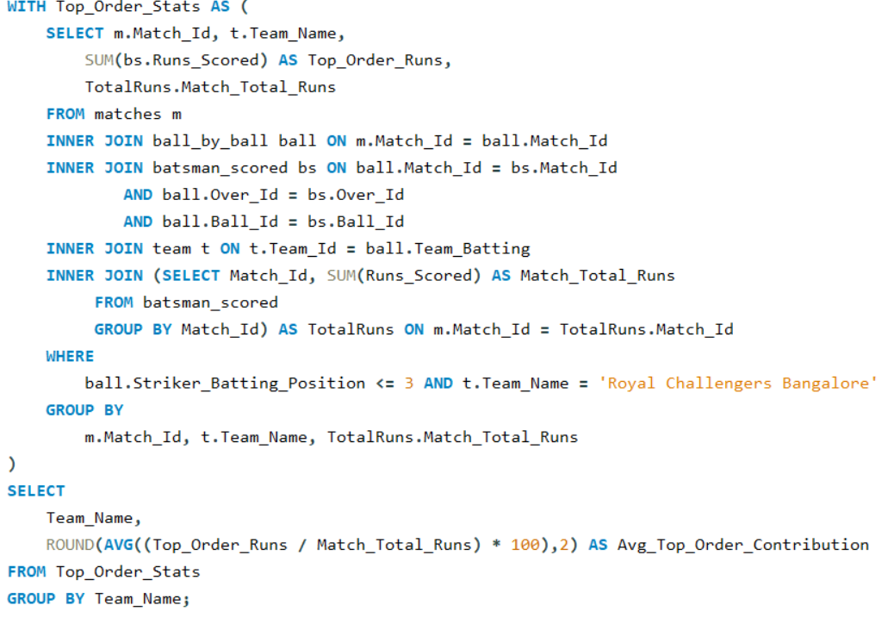

**Output 1:**



* + The average contribution of the top three batsmen is approximately **54.79%** of the team's total runs.
  + Indicates the consistency and impact of RCB’s top order, with higher values reflecting stability at the top.

**Query 2: Batting Performances**

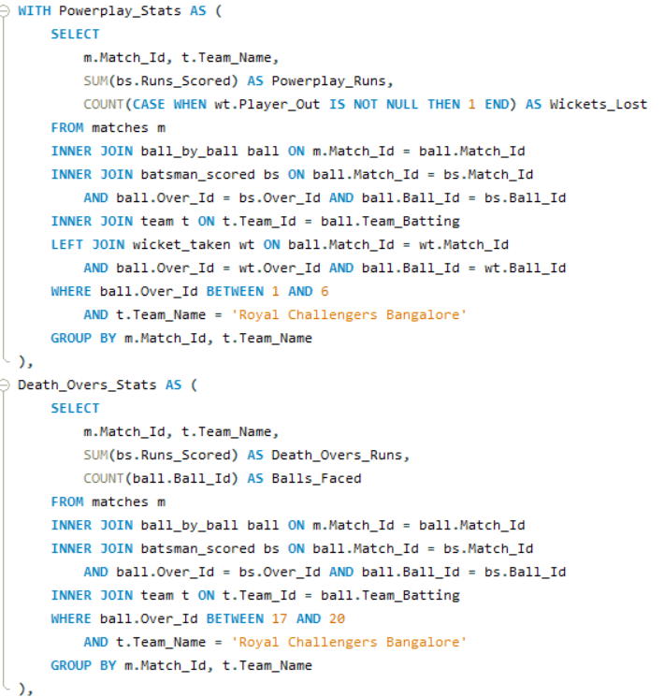

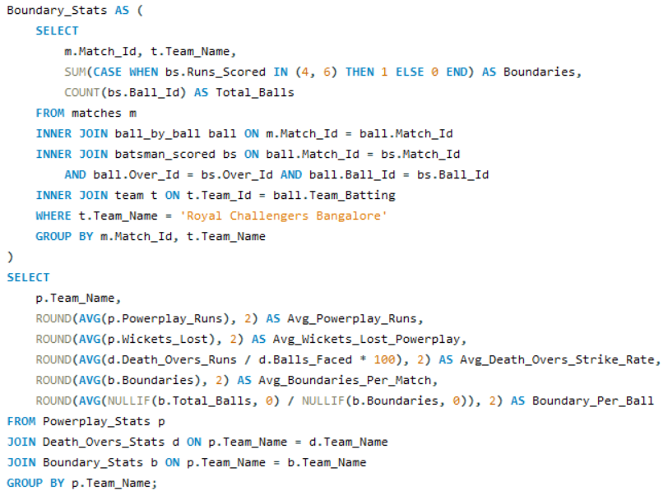

**Output 2:**



* + **Average Runs in Powerplay**: **81.31** runs
  + **Average Wickets Lost in Powerplay**: **5.55** wickets
  + **Average Strike Rate in Death Overs**: **168.58**
  + **Average Boundaries per Match**: **36.81** boundaries
  + **Boundary Frequency (Balls per Boundary)**: Every **6.28** balls

**Query 3: Different Phase Economy (Bowling Performances)**

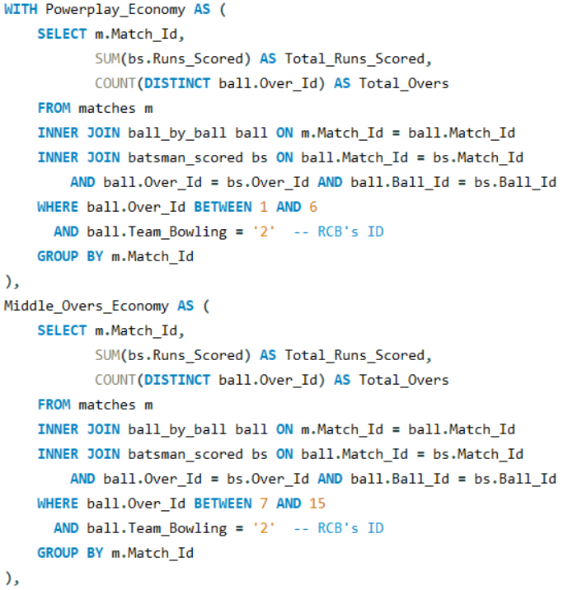

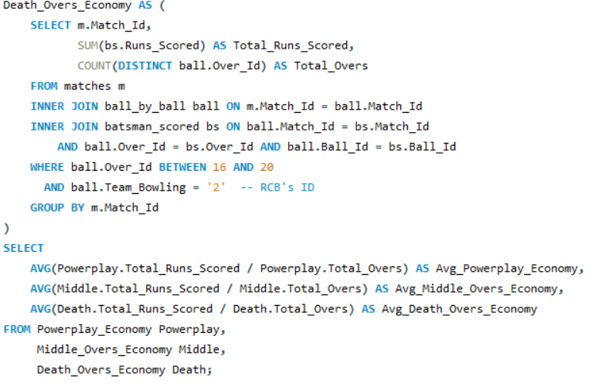

**Output 3:**



* **Powerplay Economy Rate**: **13.72** runs per over
* **Middle Overs Economy Rate**: **14.58** runs per over
* **Death Overs Economy Rate**: **17.33** runs per over

Each KPI reflects RCB's team strategies, highlighting their strengths and areas for improvement.

1. **Using SQL, write a query to find out average wickets taken by each bowler in each venue. Also rank the gender according to the average value.**

To generate a report that shows the average wickets taken by each bowler at each venue. Additionally, rank the bowlers based on their average wickets per match in descending order.

**Required Tables:**

* **player**: Contains player details such as Player_Id and Player_Name.
* **ball_by_ball**: Records every delivery in a match, with Bowler as Player_Id, Match_Id, Over_Id, and Ball_Id.
* **matches**: Holds match details, including Match_Id and Venue_Id.
* **wicket_taken**: Records information about wickets taken, including Match_Id, Over_Id, Ball_Id, and Player_Out.
* **venue**: Contains venue details with Venue_Id and Venue_Name.

**Query Strategy:**

1. **Calculate Average Wickets per Venue**:

* Created a Common Table Expression (CTE) named AvgWicketsPerVenue to calculate the average wickets taken by each bowler at each venue.
* Joined tables to get relevant data for each bowler, match, and venue.
* Used COUNT(wt.Player_Out) to calculate the total wickets taken by each bowler at each venue.
* Used COUNT(DISTINCT m.Match_Id) to calculate the total matches each bowler played at each venue.
* Calculated Avg_Wickets as the ratio of total wickets to total matches per bowler per venue.

1. **Assign Ranking**:

* In the main query, applied the RANK() window function to assign a rank based on the Avg_Wickets for each bowler, in descending order, across all venues.
* Sorted the output by Wicket_Rank for easy readability.

**Query:**

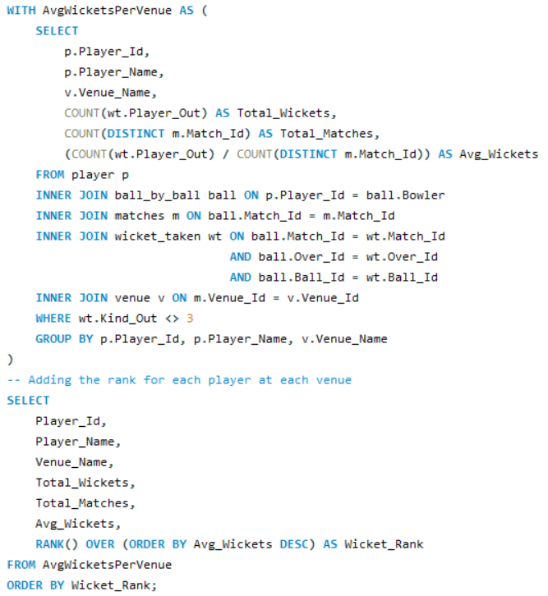

**Output:**

This output displays each bowler's average wickets per match across various venues, with bowlers ranked by performance. The Wicket_Rank column enables quick identification of top-performing bowlers based on average wickets per match at each venue.

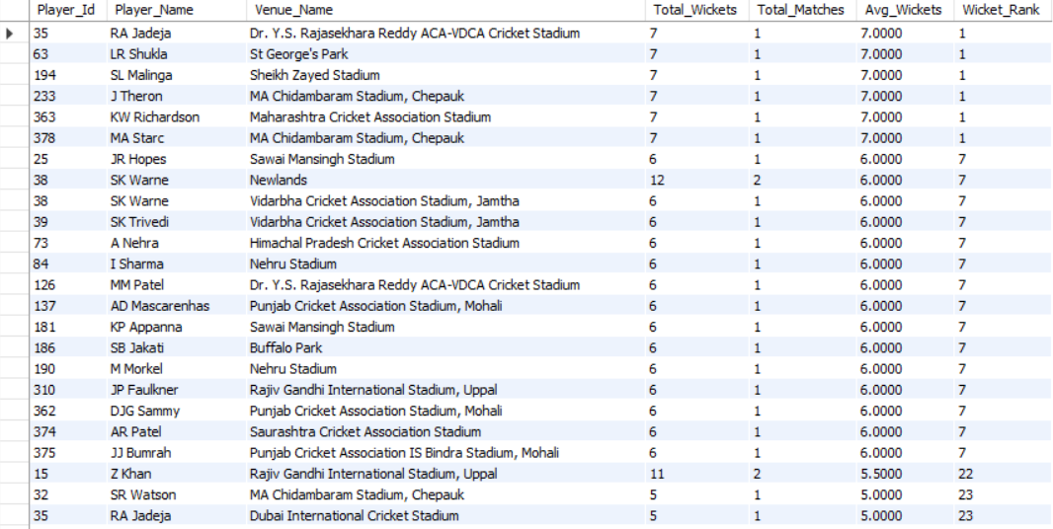

1. **Which of the given players have consistently performed well in past seasons? (will you use any visualisation to solve the problem)**

To identify players who have consistently performed well over past seasons, based on their average runs scored and average wickets taken per season.

**Required Tables:**

* **player**: Contains player details such as Player_Id and Player_Name.
* **ball_by_ball**: Records every ball in each match, with columns Striker and Bowler as Player_Id.
* **batsman_scored**: Holds information on runs scored per ball with columns Match_Id, Over_Id, Ball_Id, and Runs_Scored.
* **wicket_taken**: Records information on wickets taken, including Match_Id, Over_Id, Ball_Id, and Player_Out.
* **matches**: Contains match details, including Match_Id and Season_Id.
* **season**: Contains season information, including Season_Id and Season_Year.

**Query Strategy:**

1. **Aggregate Player Performance by Season**:
   * Created a CTE Player_Season_Performance to calculate each player’s total runs scored, total wickets taken, and matches played per season.
   * Joined the relevant tables to capture each player's runs scored (when they are the striker) and wickets taken (when they are the bowler and a player is out).
   * Aggregated results by player and season year.
2. **Calculate Season Averages**:
   * Created another CTE Player_Stats to calculate each player's average runs per season and average wickets per season over all seasons played.
   * Counted the total number of seasons each player participated in.
3. **Display Top Consistent Performers**:
   * Selected the top 10 players by their average runs and wickets per season.
   * Ranked players based on descending average runs and wickets to identify consistent high performers.

**Query:**

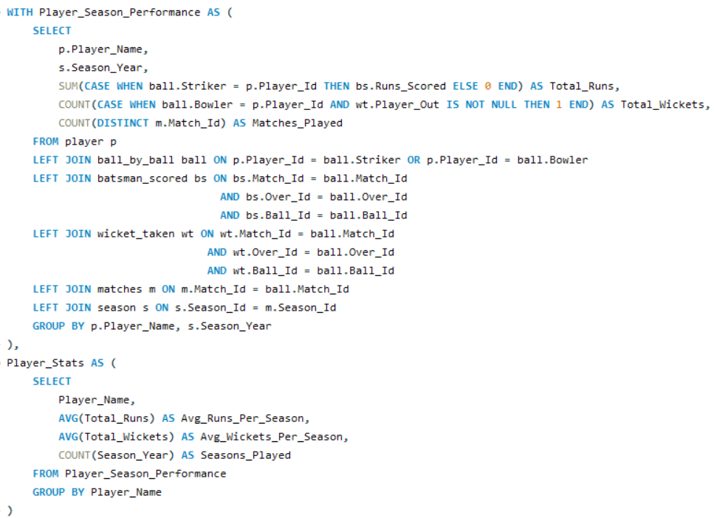

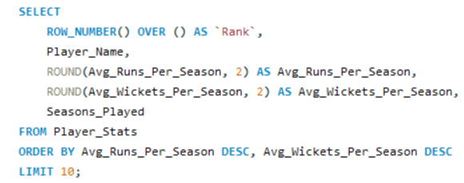

**Output:**

The query output presents the top 10 players with consistently high average runs and average wickets across seasons. Each player’s performance is evaluated based on their average runs per season and average wickets per season, along with the number of seasons they’ve played, giving insight into their consistency and contribution to the team's success.

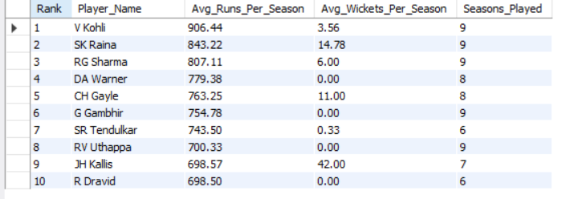

1. **Are there players whose performance is more suited to specific venues or conditions? (how would you present this using chart?)**

To determine if certain players perform better in specific venues or under particular conditions. This information can help teams strategize by selecting players who excel in given environments.

**Required Tables:**

* **player**: Contains player details, including Player_Id and Player_Name.
* **ball_by_ball**: Provides ball-level data for each match, identifying both striker and bowler.
* **batsman_scored**: Records the runs scored on each ball.
* **wicket_taken**: Logs details of wickets taken, including the player who got out.
* **matches**: Holds information on each match, including venue details.
* **venue**: Contains venue-specific data, with Venue_Id and Venue_Name.

**Query Strategy:**

1. **Player Performance Calculation**: A Common Table Expression (CTE) named Player_Performance is created to calculate each player's average runs per match and total wickets taken at each venue.

* Used conditional aggregation:

1. Calculated Avg_Runs_Per_Match for each player at each venue, focusing on when the player was the striker.
2. Counted total wickets taken by each player at each venue when the player was the bowler.
3. **Joining Relevant Tables**:

* **player** table is joined with **ball_by_ball**, **matches**, **batsman_scored**, and **venue** to get player-level performance metrics at different venues.

1. **Final Output**: Displayed each player’s name, venue, average runs per match, and total wickets at each venue. Sorted by average runs per match (descending) and then by wickets taken.

**Query:**

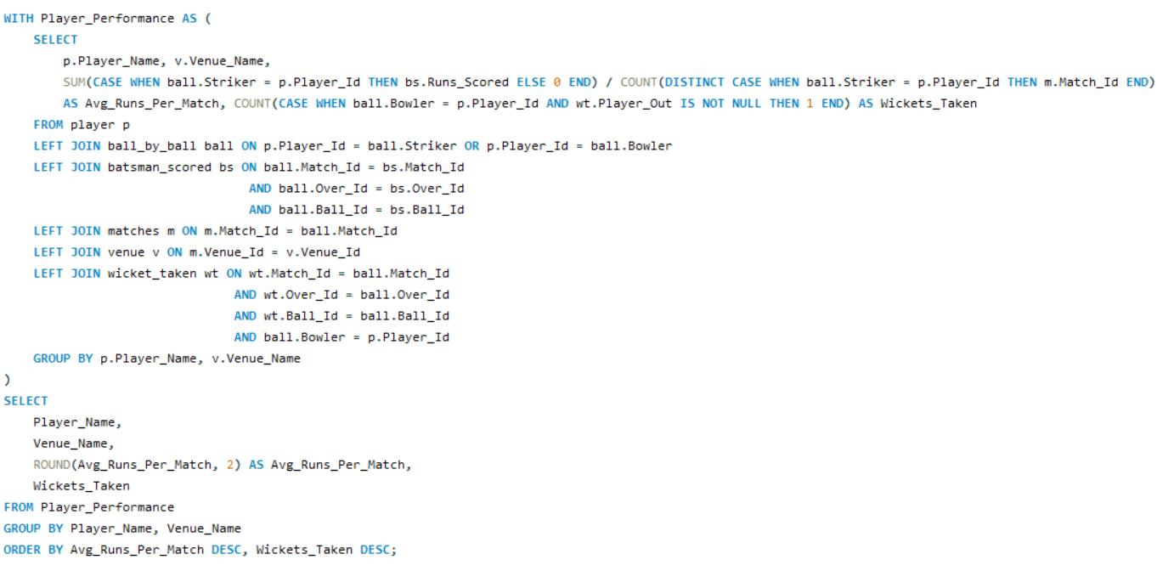

**Output:**

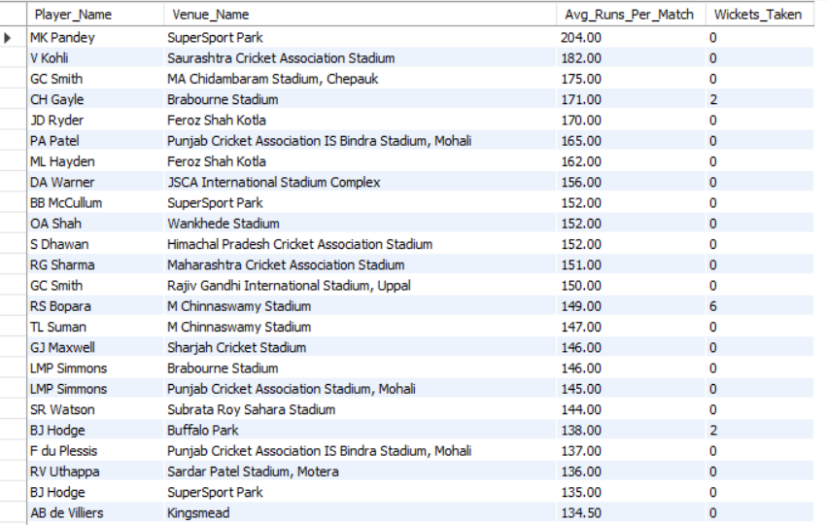

This query output includes each player's average runs scored per match and total wickets taken at various venues, allowing for insights into players who may be better suited for specific venues.

**SUBJECTIVE QUESTIONS**

1. **How does toss decision have affected the result of the match ? (which visualisations could be used to better present your answer) And is the impact limited to only specific venues?**

To analyze how toss decisions (batting or fielding first) have impacted match outcomes across different venues, identifying whether winning the toss correlates with a higher likelihood of winning the match. This analysis also examines if the impact varies by venue.

**Required Tables:**

* **matches**: Contains match details, including the team that won the toss, toss decision, and match winner.
* **toss_decision**: Stores toss decision types, such as bat or field.
* **venue**: Holds information about match venues.

**Query Strategy:**

1. **Calculate Win Statistics Based on Toss Decision**:

* Created a Common Table Expression (CTE) named Toss_Win_Stats to summarize match outcomes based on toss decisions for each venue.
* Aggregated data to count the total matches per venue and toss decision type.
* Used conditional aggregation to count matches where the toss-winning team also won the match.
* Calculated the percentage of wins after winning the toss (Win_Percentage) to gauge the success rate associated with each toss decision at each venue.

1. **Filter and Order Results**:
   * Selected only records with at least 10 matches to ensure statistical significance.
   * Ordered results by win percentage in descending order, then by the total number of matches to highlight venues with stronger correlations between toss decisions and match outcomes.

**Query:**

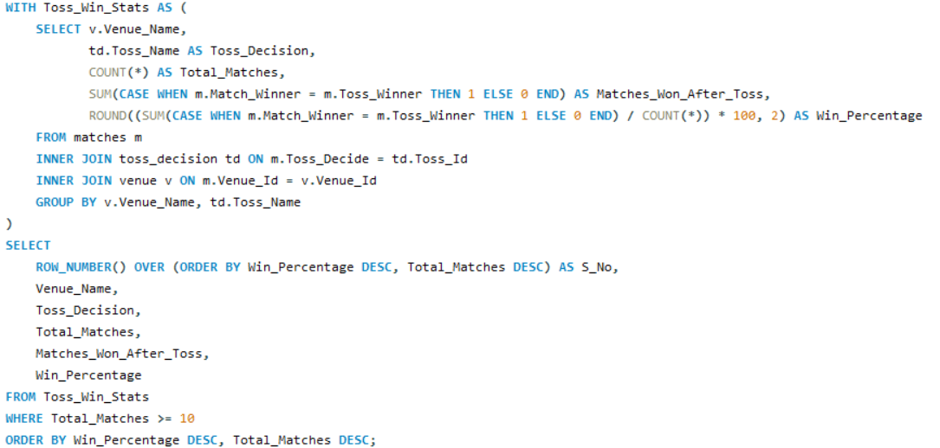

**Output:**

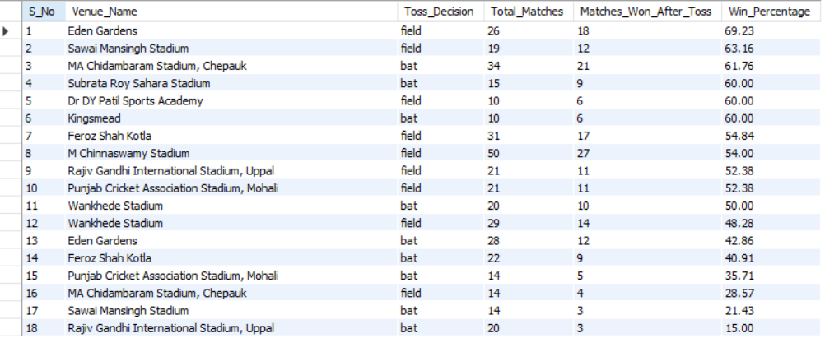

This query output reveals the success rate of winning a match after winning the toss, broken down by venue and toss decision, showing if the advantage is more pronounced in specific locations.

1. **Suggest some of the players who would be best fit for the team?**

To identify players who would be ideal fits for the team based on their consistent performance, particularly those with significant batting and bowling contributions. Criteria include players with over 2000 runs or more than 100 wickets, as these metrics indicate strong performance across matches.

**Required Tables:**

* **player**: Contains details of individual players.
* **player_match**: Links players with matches they participated in.
* **team**: Lists team information for each player.
* **matches**: Provides match-specific data.
* **ball_by_ball**: Details actions in each ball, including the bowler and striker.
* **batsman_scored**: Records runs scored by batsmen.
* **wicket_taken**: Stores information on wickets taken by bowlers.

**Query Strategy:**

1. **Aggregate Player Performance**:
   * Created a Common Table Expression (CTE) Player_Stats to calculate total runs scored, total wickets taken, and matches played for each player within their team.
   * Used SUM and CASE statements to accumulate:
     + Total runs for players acting as the striker.
     + Total wickets for players acting as the bowler and involved in wicket-taking deliveries.
   * Filtered players by those who met either the run threshold (2000 runs) or wicket threshold (100 wickets).
2. **Retrieve Top Players**:

* Selected only players meeting the above criteria.
* Ordered by total runs (desc) and total wickets (desc) to emphasize all-round performance.
* Limited output to the top 30 players based on the sorting criteria.

**Query:**

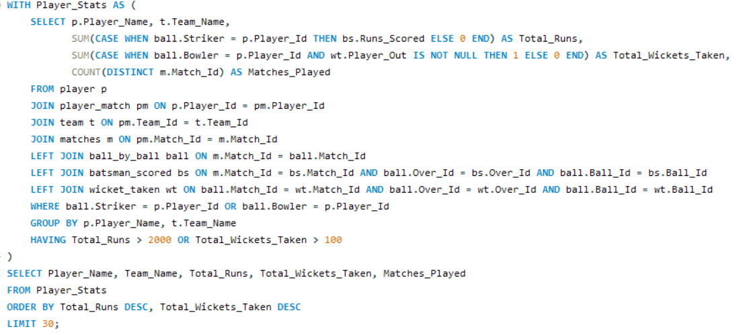

**Output:**

The output provides a list of players with high batting and/or bowling contributions, along with the team name, total runs, total wickets, and matches played. This allows the team to consider players who can add substantial value in both departments.

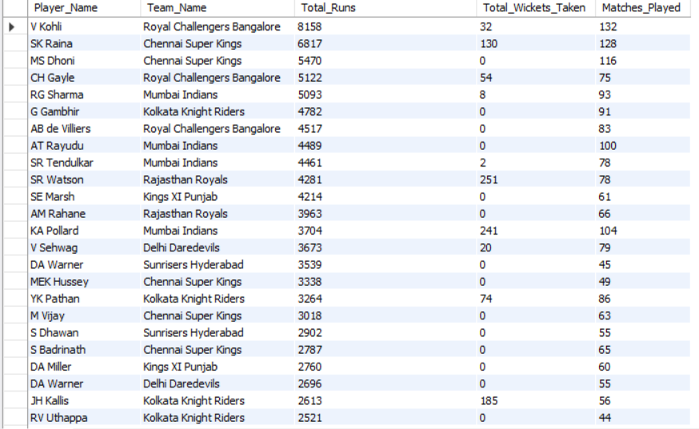

**Player Recommendations for Ideal Team Fit**

* **All-Rounders with High Batting and Bowling Contributions:**
  + **SR Watson (Rajasthan Royals)**: With 4,281 runs and 251 wickets, Watson is an exceptional all-rounder. His ability to impact both batting and bowling makes him highly valuable.
  + **KA Pollard (Mumbai Indians)**: Pollard’s 3,704 runs and 241 wickets highlight his capability as a power hitter and a dependable bowler, making him a versatile option.
  + **JH Kallis (Kolkata Knight Riders/Royal Challengers Bangalore)**: Kallis’ all-round contribution reflects his consistency across teams and seasons.
* **Top Batting Contributors:**
  + **V Kohli (Royal Challengers Bangalore)**: Kohli’s remarkable 8,158 runs underscore his consistency and reliability as a batsman, making him a critical choice for a top-order position.
  + **SK Raina (Chennai Super Kings)**: With 6,817 runs and 130 wickets, Raina is another strong performer, especially in high-stakes matches. His all-around contributions add depth to the batting and bowling line-ups.
  + **MS Dhoni (Chennai Super Kings)**: Although Dhoni has not contributed with wickets, his 5,470 runs and extensive experience as a captain and finisher bring exceptional strategic value.
* **Specialist Bowlers with Moderate Batting Skills:**
  + **YK Pathan (Kolkata Knight Riders)**: With 3,264 runs and 74 wickets, Pathan can contribute with the bat in middle-order positions while also being a reliable bowler.
  + **RV Uthappa (Kolkata Knight Riders/Pune Warriors)**: Uthappa’s consistent batting performance (over 2,500 runs) and occasional wicket-taking ability make him a valuable addition, especially for top-order flexibility.
* **High-Impact Batsmen:**
  + **DA Warner (Delhi Daredevils/Sunrisers Hyderabad)**: Warner’s record (3,539 and 2,696 runs across teams) shows his adaptability and explosive batting potential, which is ideal for opening or top-order roles.
  + **CH Gayle (Royal Challengers Bangalore)**: Known for his high strike rate, Gayle’s 5,122 runs make him a strong opener who can change the course of a game with aggressive batting.

Based on these player profiles, the recommended focus should be on recruiting consistent performers who can contribute to both batting and bowling. All-rounders like Watson and Pollard provide flexibility, while batsmen like Kohli and Warner ensure a strong batting line-up. These selections would enhance RCB's chances by balancing the team across all aspects.

1. **What are some of parameters that should be focused while selecting the players?**

To identify key performance parameters for selecting players based on both batting and bowling metrics. This selection criteria will provide a comprehensive view of players' effectiveness, consistency, and potential contributions in matches.

**Required Tables:**

* **player**: Contains details of individual players.
* **ball_by_ball**: Tracks each action in the game, including striker and bowler details for each ball.
* **batsman_scored**: Records runs scored by batsmen in each ball.
* **wicket_taken**: Logs details of each wicket taken by bowlers.

**Query Strategy:**

1. **Calculate Batting Metrics**:
   * **Total Runs**: Sum of runs scored by the player while batting.
   * **Average Runs per Match**: Total runs divided by the number of matches the player batted in.
   * **Strike Rate**: Runs scored per 100 balls faced, calculated by dividing total runs by total balls faced and multiplying by 100.
2. **Calculate Bowling Metrics**:
   * **Total Wickets**: Number of wickets taken by the player as a bowler.
   * **Bowling Average**: Runs conceded by the player per wicket, calculated by dividing total runs conceded by the number of wickets taken.
   * **Bowling Strike Rate**: Balls bowled per wicket taken, calculated by dividing total balls bowled by total wickets.
3. **Output Results**:
   * Selected players are ordered by **Total Runs** in descending order to highlight high-scoring batsmen, while also considering their bowling metrics for a well-rounded evaluation.

**Query:**

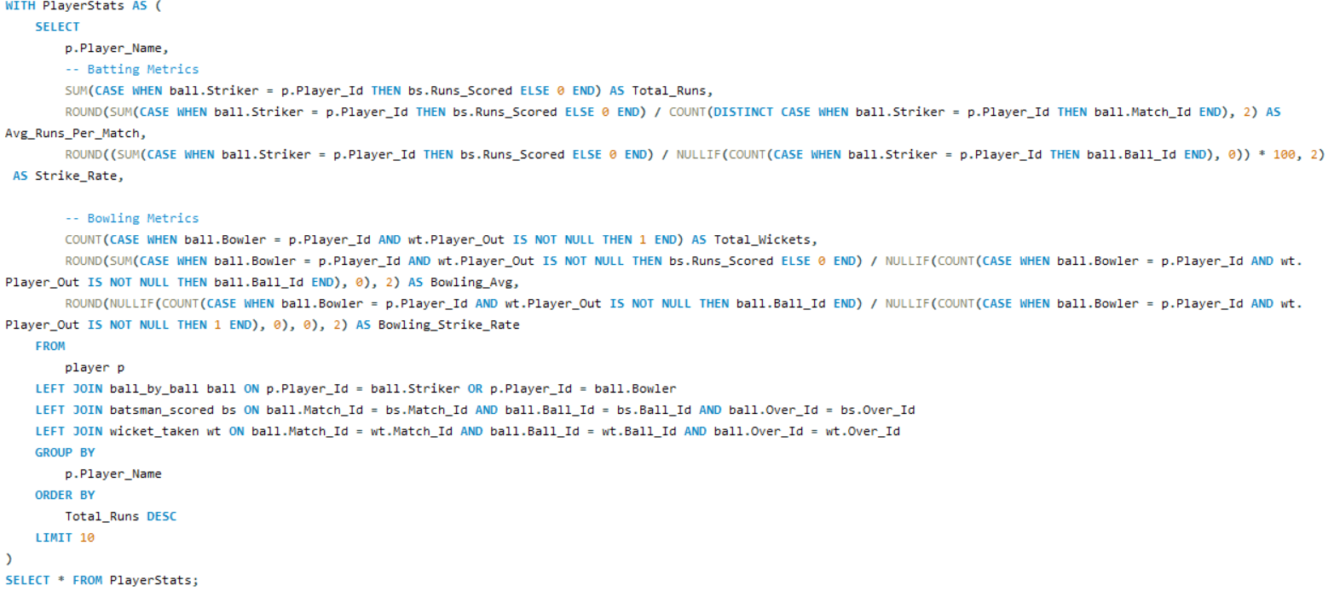

**Output:**

The **output** for this query would include a list of players with their calculated metrics for batting and bowling. This output will allow for a balanced evaluation of players who perform well both with the bat and ball, which can guide selection based on comprehensive performance data.

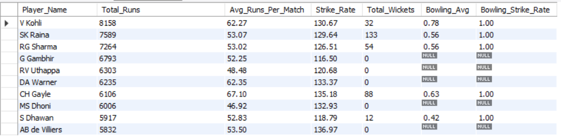

1. **Which players offer versatility in their skills and can contribute effectively with both bat and ball? (can you visualize the data for the same)**

Identify players who demonstrate versatility by significantly contributing with both bat and ball, making them valuable all-rounders for a team. This analysis seeks to highlight players who score consistently high in both batting and bowling metrics, providing an advantage through balanced skill sets.

**Required Tables:**

1. **player**: Contains information on player names and IDs.
2. **ball_by_ball**: Holds ball-by-ball data, including the striker, bowler, and associated match details.
3. **batsman_scored**: Provides runs scored for each ball by the batsman.
4. **wicket_taken**: Stores information about wickets taken during each ball.
5. **matches**: Contains details on each match, including the match ID.

**Query Strategy:**

1. **Calculate Batting Performance**:

* For each player, sum the total runs scored when they are listed as the striker in ball_by_ball.
* Calculate the average runs per match by dividing total runs by the count of distinct matches played as the striker.

1. **Calculate Bowling Performance**:

* Sum the total wickets taken by counting instances where the player, as a bowler, is associated with a Player_Out in wicket_taken.
* Calculate average wickets per match by dividing total wickets by the count of distinct matches played as the bowler.

1. **Filter for Versatility**:

* Only select players with a minimum of 500 runs and 30 wickets, indicating substantial contributions in both batting and bowling.

1. **Order and Display Results**:

* Sort by Total_Wickets in descending order, followed by Total_Runs, to prioritize players with higher wicket counts.
* Display columns for Player_Name, Total_Runs, Total_Wickets, Avg_Runs_Per_Match, and Avg_Wickets_Per_Match.

**Query:**

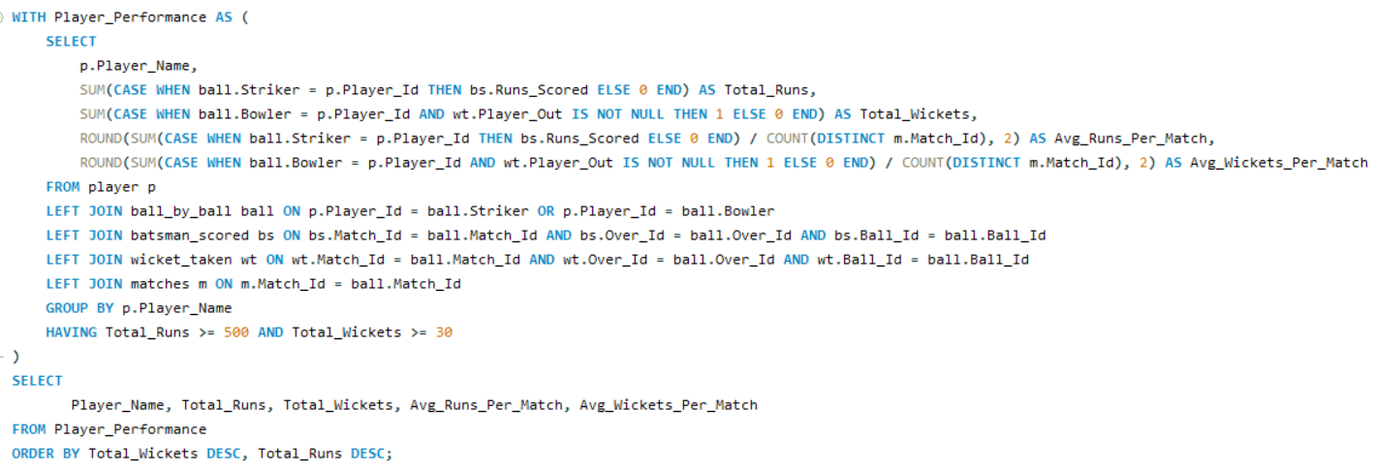

**Output:**

The output of this query will list players who demonstrate versatility by contributing significantly in both batting and bowling, based on total runs scored and total wickets taken. The criteria for selection are set as a minimum of 500 runs and 30 wickets.

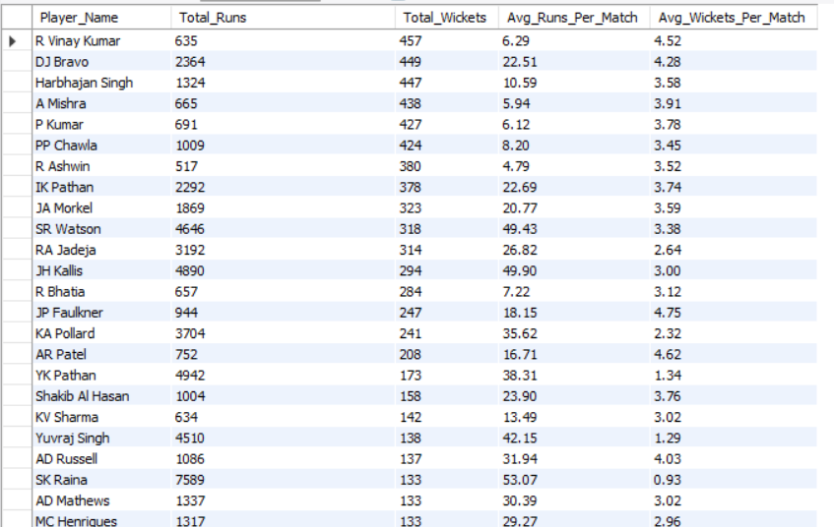

**Recommendation for Versatile Players with Batting and Bowling Skills**

The following players show a strong balance of skills in both batting and bowling, making them ideal all-rounders. These players contribute consistently in matches and offer the flexibility to adapt to various game scenarios. Here’s a breakdown of key recommendations:

1. **High-Impact All-Rounders with Strong Batting and Bowling:**
   * **SR Watson**: With 4,646 runs and 318 wickets, Watson stands out as a powerful all-rounder, boasting high averages in both runs per match (49.43) and wickets per match (3.38). His consistency in both departments adds substantial value to any team.
   * **DJ Bravo**: Known for his versatility, Bravo’s 2,364 runs and 449 wickets (averaging 4.28 wickets per match) highlight his dual skills. He can take crucial wickets while providing depth to the middle-order batting.
   * **JH Kallis**: With 4,890 runs and 294 wickets, Kallis is another exceptional all-rounder who can both anchor the innings and deliver with the ball. His average runs per match (49.9) makes him valuable for stabilizing the batting line-up.
2. **Players with Reliable Bowling and Effective Batting:**
   * **JP Faulkner**: With 944 runs and 247 wickets, Faulkner brings strength to both batting and bowling, with a high average in wickets per match (4.75). His versatility is suited for both attacking and defensive plays.
   * **AD Russell**: Known for his explosive batting, Russell’s 1,086 runs and 137 wickets make him a high-impact player. His average runs per match (31.94) and wickets per match (4.03) illustrate his effectiveness in both departments.
   * **IK Pathan**: With 2,292 runs and 378 wickets, Pathan provides solid backup as a batsman while maintaining his reliability in bowling. His average runs per match (22.69) and wickets per match (3.74) make him a valuable addition for balanced team composition.
3. **Players Who Provide Steady Contributions in Both Departments:**
   * **Harbhajan Singh**: With 1,324 runs and 447 wickets, Harbhajan is known for his effective spin bowling and can contribute runs in the lower order. His average wickets per match (3.58) enhances his value in challenging match situations.
   * **Shakib Al Hasan**: With 1,004 runs and 158 wickets, Shakib’s performance as an all-rounder is dependable, with a balanced average of 23.9 runs and 3.76 wickets per match, making him a strategic choice for both batting and bowling.
4. **Emerging All-Rounders:**
   * **RA Jadeja**: Known for his agility and fielding, Jadeja’s 3,192 runs and 314 wickets reflect his growing reputation as a valuable all-rounder. His average runs per match (26.82) and wickets per match (2.64) show his consistency in contributing to the team’s balance.
   * **PP Chawla**: With 1,009 runs and 424 wickets, Chawla’s skills add depth in both batting and spin bowling, making him suitable for middle-order positions and crucial wicket-taking in bowling.

The recommended players show high versatility, with impactful contributions in both batting and bowling. All-rounders like SR Watson, DJ Bravo, and JH Kallis provide strategic flexibility, while players such as AD Russell and Shakib Al Hasan offer reliability in varied match scenarios. These players would strengthen the team's adaptability and provide a balanced approach for both offensive and defensive strategies.

1. **Are there players whose presence positively influences the morale and performance of the team? (justify your answer using visualisation)**

Identify players whose presence has a measurable positive impact on their team’s performance, particularly by evaluating the team's win percentage when they are included in matches. The goal is to determine if certain players are correlated with higher win rates, suggesting their influence on team morale and success.

**Required Tables:**

1. **player**: Provides player information such as names and IDs.
2. **player_match**: Contains data on which players participated in each match, including team association.
3. **matches**: Includes match outcomes, identifying the winning team and match details.
4. **team**: Provides team names and IDs.

**Query Strategy:**

1. **Calculate Team Wins with Each Player**:
   * Count the total matches played by each player for their respective team from player_match and matches.
   * Sum the matches where the player’s team won to determine the number of wins associated with each player's participation.
   * Filter to include only completed matches (Outcome_type = 1).
2. **Calculate Win Percentage**:
   * For each player, calculate the win percentage by dividing Matches_Won by Total_Matches and multiplying by 100.
   * Only include players with more than 5 matches to ensure sufficient data for meaningful results.
3. **Display Results**:
   * Select the top 15 players sorted by win percentage, displaying Player_Name, Team_Name, Total_Matches, Matches_Won, and Win_Percentage.

**Query:**

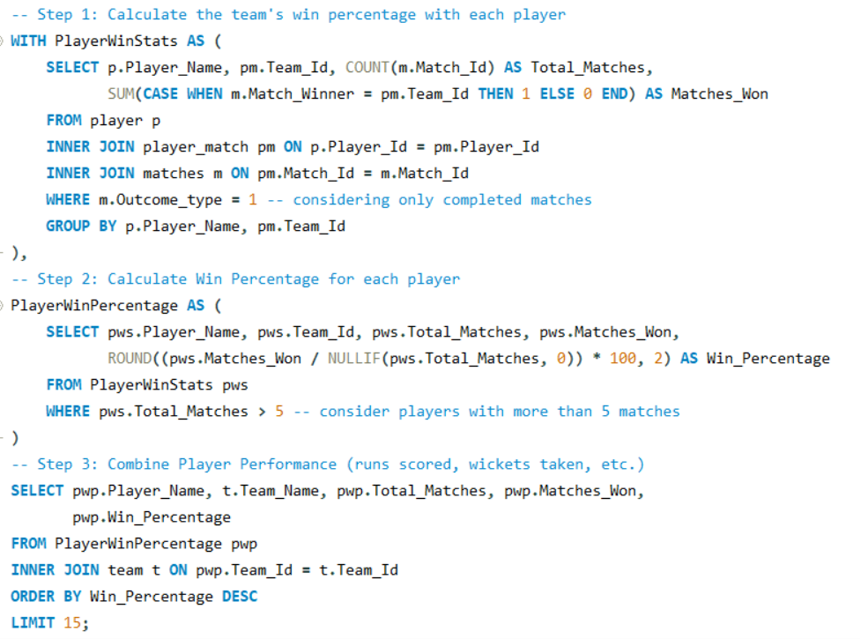

**Output:**

The query provided would produce an output listing the top 15 players with the highest team win percentages when they played

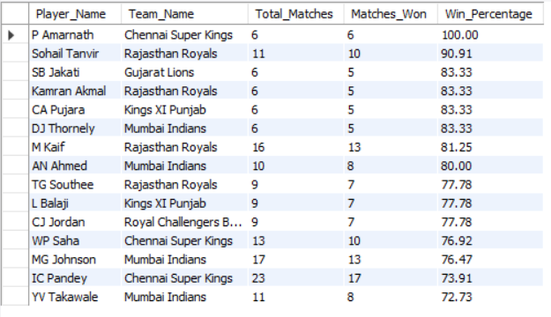

1. **What would you suggest to RCB before going to mega auction?**

Before RCB heads to the mega auction, the following strategic recommendations can guide them in making valuable selections:

1. **Focus on Multi-skilled Players**:

* Prioritize players who contribute both with bat and ball, as they add depth to the team and offer flexibility in squad balance. Visualizations, such as a scatter plot comparing players’ batting and bowling performances (e.g., runs scored vs. wickets taken), can highlight versatile players.

1. **Prioritize Power Hitters for Middle Overs**:

* RCB has traditionally relied heavily on top-order performance. They should target reliable power hitters for the middle order who can maintain a strong strike rate under pressure. A bar chart showing potential players' strike rates and average scores in overs 10-15 could help identify impactful players for this role.

1. **Strengthen Death Bowling**:

* Death bowling has been a weak spot for RCB in past seasons. They should aim to secure bowlers with high death-over wicket-taking ability and economical performance in the last 5 overs. Line graphs showing economy rates and wickets taken in death overs for target players can visually aid in choosing the right candidates.

1. **Seek Players with Proven Performance at Home Venues**:

* Players who perform well in the Chinnaswamy Stadium’s conditions (high-scoring pitch, smaller boundaries) will be an asset. Filtering players based on past performance at this venue and visualizing their averages and strike rates at similar high-scoring venues could help pinpoint ideal candidates.

1. **Consider Players with Strong Morale-boosting Presence**:

* Team dynamics are crucial for RCB's consistent performance. Identifying players whose presence has positively influenced past teams’ win percentages can improve team morale. Win percentage charts of players with their respective teams over multiple seasons would be beneficial for selecting such players.

1. **Balance Experience with Emerging Talent**:

* RCB could invest in emerging players with high potential while retaining a core of experienced players. A radar chart displaying experience factors (matches played, years of experience) alongside key performance metrics (average, economy, strike rate) could help achieve this balance.

These data-backed strategies would support RCB in creating a well-rounded, resilient team structure in the auction.

1. **What do you think could be the factors contributing to the high-scoring matches and the impact on viewership and team strategies?**

Several factors contribute to high-scoring matches in cricket, especially in T20 leagues like the IPL, which impact both viewership and team strategies. Here are key contributing elements and their effects:

1. Pitch Conditions

* **Flat Pitches**: Favour batsmen, leading to higher scores. Flat pitches, particularly in venues like Chinnaswamy Stadium in Bangalore, support stroke play due to low seam movement and predictable bounce.
* **Impact**: High scores make matches more exciting, attracting more viewers. Teams are more likely to strategize around batting depth and choose power hitters for flat-pitch venues.

2. Smaller Boundaries

* **Boundary Dimensions**: Smaller stadiums make it easier for batsmen to clear the boundary, resulting in more fours and sixes, which quickly increase the total score.
* **Impact**: This leads to more thrilling, high-scoring games, capturing viewers' attention. Teams often build squads with hard-hitters capable of exploiting small boundaries and target high boundary percentages in their game plans.

3. Player Skill Levels and Batting Depth

* **Strong Batting Line-ups**: Teams with power hitters and deep batting orders can post big totals, maintaining aggression from start to end.
* **Impact**: With stronger batting line-ups, teams may adopt aggressive strategies, aiming for high run rates. Viewers are drawn to this intensity, particularly in nail-biting finishes.

4. Advances in Batting Techniques and Equipment

* **Bat Technology and Shots Innovation**: Modern bats and techniques (like switch hits and scoops) allow batsmen to score runs faster.
* **Impact**: This adds excitement and unpredictability, boosting viewership. Teams may prioritize players skilled in innovative shots, especially in death overs.

5. High Altitude and Weather Factors

* **Altitude Effects**: In venues at higher altitudes, the ball travels farther, aiding batsmen in hitting boundaries more easily.
* **Weather Conditions**: Humid weather or dew in night games makes bowling and fielding tougher, often favouring the batting side.
* **Impact**: Teams adjust strategies, like choosing to bowl first in dewy conditions, to maintain control. This adaptability appeals to viewers, who enjoy seeing how teams tackle varying conditions.

6. Shorter Game Format

* **Nature of T20**: In T20, every ball count, pushing batsmen to be aggressive and increasing the overall scoring rate.
* **Impact**: This format’s fast-paced nature ensures constant excitement, making it ideal for high viewership. Teams may select players skilled in maintaining high strike rates and set aggressive powerplay and death-over strategies.

Impact on Viewership and Team Strategies

* **Increased Viewership**: High-scoring matches with thrilling chases and frequent boundaries are highly appealing, keeping fans engaged for the duration of the match.
* **Enhanced Fan Engagement**: High scores and close chases result in more engaging, memorable moments, boosting fan engagement on social media and through in-game events.
* **Strategic Shift Towards Batting Depth**: Teams may focus on recruiting big-hitters and developing a long batting line-up to capitalize on favourable scoring conditions.
* **Dynamic Use of Analytics**: Teams use data to optimize batting strategies based on venue conditions and opponent weaknesses, targeting ideal line-ups and shot selections.

1. **Analyze the impact of home ground advantage on team performance and identify strategies to maximize this advantage for RCB.**

The goal is to analyse the impact of home ground advantage for Royal Challengers Bangalore (RCB) by examining performance at the M. Chinnaswamy Stadium. Key factors include how pitch conditions, boundary size, and crowd support influence match outcomes. Additionally, this analysis aims to identify strategies that RCB can adopt to maximize their success at their home venue.

**Required Tables:**

* **matches**: Stores details of each match, including Match_Id, Team_1, Team_2, Venue_Id, Match_Winner, and Outcome_type (to confirm completed matches).
* **team**: Contains team information with Team_Id and Team_Name.
* **venue**: Holds data on match venues with Venue_Id and Venue_Name.

**Query Strategy:**

1. Create the HomeMatches CTE to count the total number of matches RCB has played at each venue and the number of matches they’ve won. Focus specifically on completed matches (Outcome_type = 1).

* Join the matches, team, and venue tables to gather the required data.
* Group by Team_Name and Venue_Name.

1. Create the WinPercentage CTE to calculate RCB's win percentage at each venue.

* Compute the win percentage as (Wins / Matches_Played) * 100.
* Filter to focus on M. Chinnaswamy Stadium to assess the home ground performance.

1. Retrieve and display results with relevant columns: Team_Name, Venue_Name, Matches_Played, Wins, and Win_Percentage, sorted in descending order of win percentage.

**Query:**

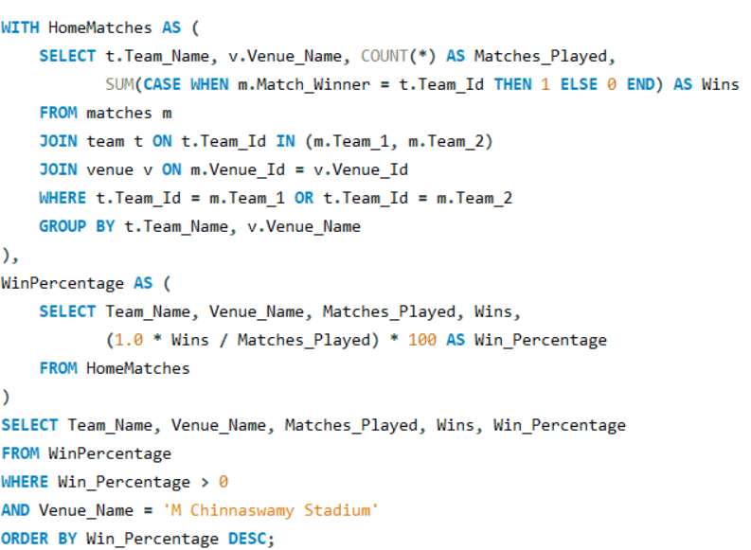

**Output:**  
The query would output a table showing RCB’s performance specifically at M. Chinnaswamy Stadium, with columns:

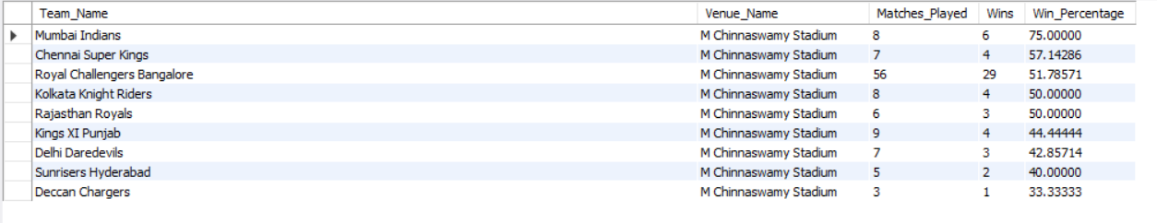

This data will show RCB's win percentage at their home ground, which helps analyse the impact of home ground advantage.

**KEY ASPECTS OF HOME GROUND ADVANTAGE FOR RCB**

1. **Pitch Characteristics**

* The Chinnaswamy pitch is batting-friendly, encouraging high run rates. RCB should prioritize a batting lineup with explosive hitters and strong death-over scorers.

1. **Boundary Size**

* Short boundaries favour big hitters and spinners who can prompt risky shots. RCB should select powerful batters and spin bowlers skilled at containing runs and inducing errors.

1. **Weather and Altitude Conditions**

* Bangalore's altitude helps the ball travel farther, which aids batsmen. Dew in night matches challenges bowlers, so RCB may benefit from chasing rather than defending.

1. **Crowd Support**

* The passionate fanbase provides morale support and pressures opponents, making Chinnaswamy a challenging venue for visiting teams.

**STRATEGIES TO MAXIMIZE HOME GROUND ADVANTAGE**

1. **Strengthening Batting Power**

* Stack the line-up with high strike-rate players and consistent six-hitters to take advantage of small boundaries.

1. **Leveraging Spin and Variation**

* Focus on spinners with variety, such as googlies, to limit scoring and create wicket opportunities.

1. **Prioritizing Quick Scoring in Powerplay and Strong Fielding**

* Quick openers and agile fielders help set a high pace and defend totals effectively in high-scoring conditions.

1. **Utilizing Death-Bowling Specialists**

* Invest in bowlers who attempts Yorkers and variations to maintain control in dew conditions.

1. **Adapting Strategies Based on Opponents**

* Tailor bowler selections and field setups based on analytics of opponent weaknesses.

1. **Boosting Morale through Fan Engagement**

* Engage fans actively to maintain high morale, adding psychological advantage and making Chinnaswamy a fortress.

1. **Come up with a visual and analytical analysis with the RCB past seasons performance and potential reasons for them not winning a trophy.**

Analysing Royal Challengers Bangalore’s (RCB) performance over IPL seasons involves studying win-loss patterns, individual player contributions, and match scenarios (home vs. away, chasing vs. defending). This analysis helps understand reasons behind RCB’s struggles to secure a title. Here’s a structured approach with query details, table requirements, and potential insights.

1. Analyse RCB’s **overall season performance**.
2. Examine **venue-wise performance**, comparing **home vs. away** matches.
3. Investigate RCB’s **success rate in chasing vs. defending** games.
4. Review **key players' contributions** (batting and bowling) seasonally.

**Required Tables:**

1. **Matches** – Match details, including IDs, seasons, winning teams, and venues.
2. **Team** – Team names and IDs.
3. **Venue** – Venue names and IDs.
4. **Player**, **Player_Match**, **Ball_By_Ball** – Player match records, including batsmen scores and wickets.

**Query Strategy Breakdown:**

**1. Season-wise Performance**

* **Objective**: Calculate RCB’s win-loss stats and win percentage for each season.
* **Query Explanation**:
  + Aggregate RCB’s matches per season.
  + Count wins and losses by checking if the match winner matches RCB’s team ID.
  + Calculate the win percentage.
* **Output**: Season_Year, Matches_Played, Matches_Won, Matches_Lost, Win_Percentage.

**2.** **Venue-wise Performance**

* **Objective**: Assess RCB’s performance across different venues.
* **Query Explanation**:
  + Group RCB’s matches by venue and count total matches and wins at each location.
  + Calculate win percentage for each venue.
* **Output**: Venue_Name, Matches_Played, Wins, Win_Percentage.

**3****. Home vs. Away Performance**

* **Objective**: Compare RCB’s performance at home (M. Chinnaswamy Stadium) vs. away/neutral venues.
* **Query Explanation**:
  + Categorize matches into Home or Away/Neutral.
  + Count total matches and wins for each category.
  + Calculate win percentage for each location type.
* **Output**: Venue_Category, Matches_Played, Wins, Win_Percentage.

**4.** **Chasing vs. Defending Performance**

* **Objective**: Analyze RCB’s record when chasing versus defending.
* **Query Explanation**:
  + Classify each match as Batting First or Batting Second based on toss decisions and outcomes.
  + Count total matches and wins for each strategy.
  + Calculate win percentage for chasing vs. defending.
* **Output**: Game_Strategy, Matches_Played, Wins, Win_Percentage.

**5.** **Key Players’ Performance Across Seasons**

* **Objective**: Track runs scored and wickets taken by RCB’s key players across seasons.
* **Query Explanation**:
  + Sum runs and count wickets for each player by season.
  + Join Ball_By_Ball data with Batsman_Scored and Wicket_Taken to retrieve batting and bowling stats.
* **Output**: Player_Name, Season_Id, Total_Runs, Total_Wickets.

**Query 1 Season wise Performance:**

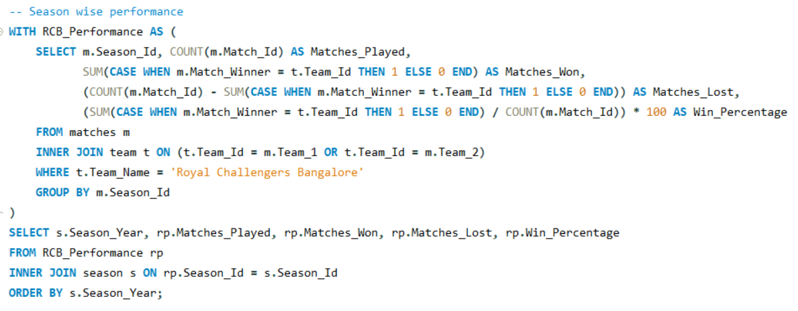

**Output 1:**

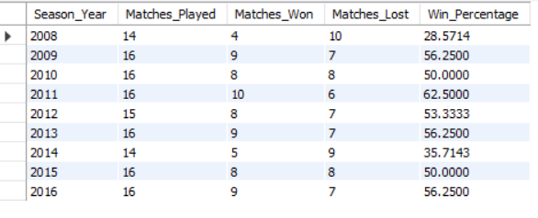

**Query 2 Venue wise Performance:**

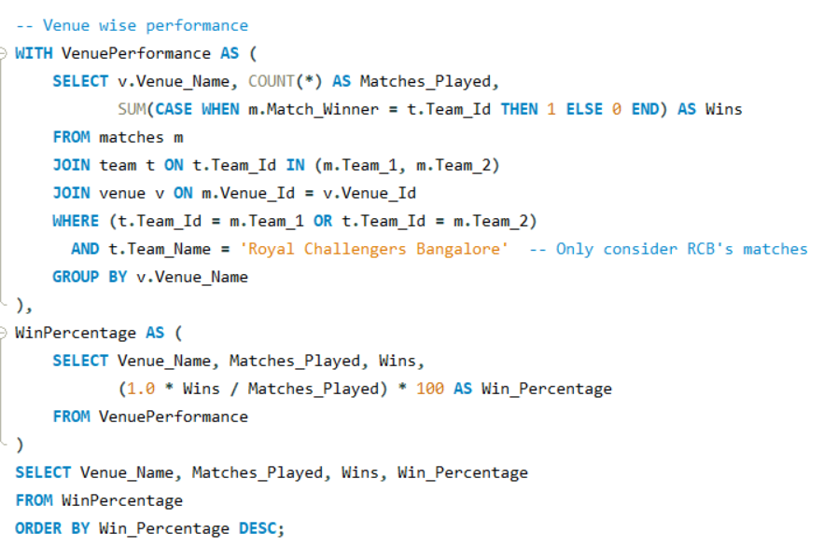

**Output 2:**

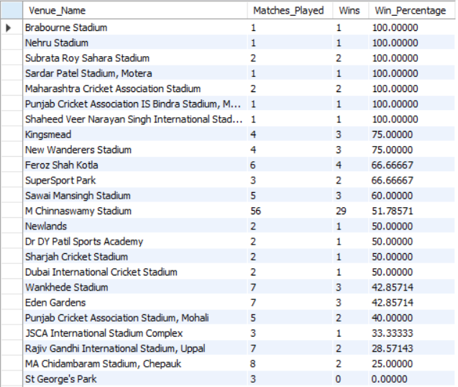

**Query 3 Home and away performance:**

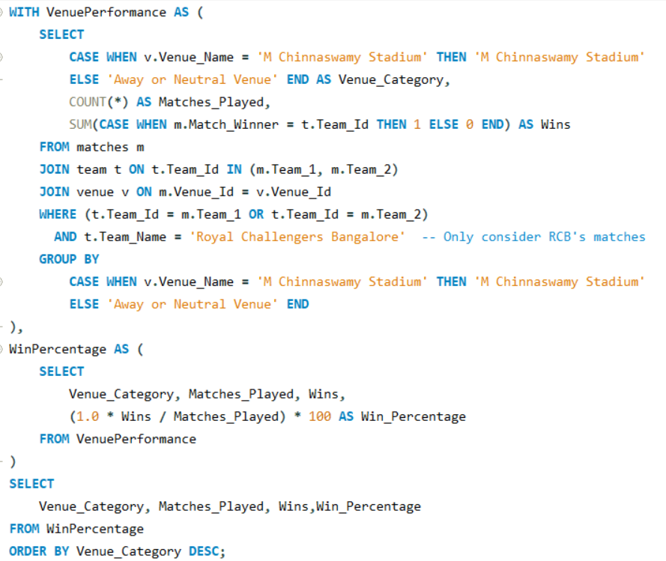

**Output 3:**

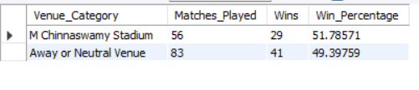

**Query 4 Chasing vs Defending:**

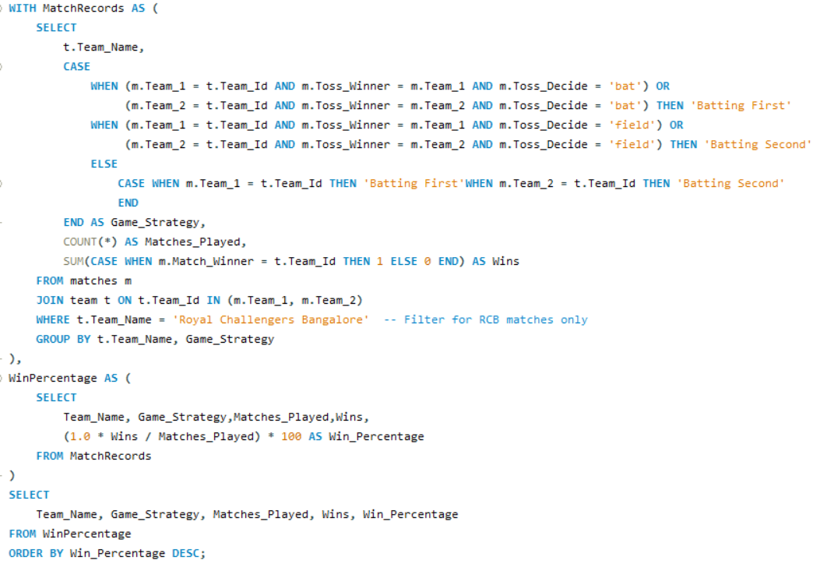

**Output 4:**

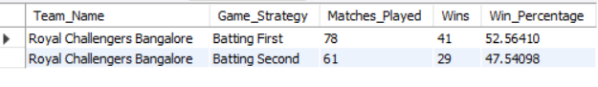

**Query 5 Performance of Key Players Across Season:**

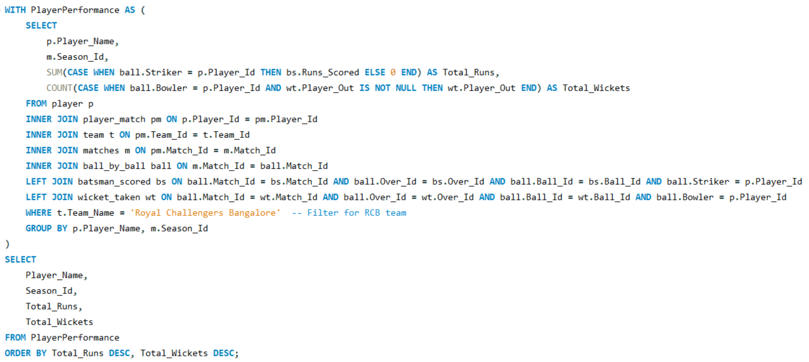

**Output 5:**

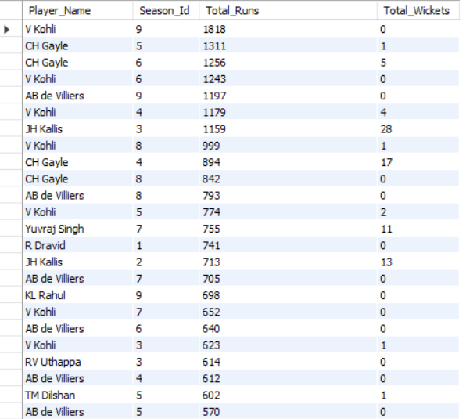

**Potential Reasons for RCB’s Title Struggles**

1. **Heavy Dependence on Key Players**:
   * Over-reliance on players like Virat Kohli and AB de Villiers might cause inconsistency.
2. **Bowling Limitations**:
   * RCB has been known for strong batting but weaker bowling, affecting their ability to defend totals.
3. **Home Ground Dependence**:
   * M. Chinnaswamy’s smaller boundaries favor batting, potentially skewing performance in high-stakes away/neutral venue matches.
4. **Inconsistency in Team Composition**:
   * Frequent player changes may disrupt team synergy, making it challenging to maintain consistent performance.

This comprehensive analysis should provide insights into RCB’s strengths, weaknesses, and patterns that could inform strategies to enhance performance and title prospects in future seasons.

1. **How would you approach this problem, if the objective and subjective questions weren't given?**

If I were to approach this problem independently, without being provided with objective or subjective questions, my strategy would include the following steps:

1. **Database Analysis**
   * I would start by conducting a comprehensive review of the entire database to understand its structure and contents. This includes examining historical data on player statistics, match outcomes, and auction results, aiming to identify any existing patterns and trends.
   * I would focus particularly on the team’s past auction strategies, looking into which players were acquired, their subsequent performances, and how effectively these acquisitions aligned with the team’s overall objectives.
2. **Strategy Assessment**
   * From past auctions, I would identify strategies that contributed to improved team performance and adapt these for current team requirements, such as addressing weaknesses or filling specific roles.
   * It would also be essential to clarify objectives for the upcoming auction, establishing what success would look like. This could involve ensuring team balance, targeting players with compatible skill sets, and aligning selections with the team’s style of play.
3. **Performance Evaluation**
   * I would analyze past team performances to uncover factors leading to both victories and losses.
   * This would include examining toss decisions and their outcomes to assess how they impacted match results, such as:
     + Calculating the total number of tosses won.
     + Assessing results categorized as Toss Win - Match Loss (TWML) or Toss Loss - Match Win (TLMW) to gauge if toss decisions influenced outcomes.
4. **Batting Analysis**
   * Reviewing the team’s record when batting first versus batting second would reveal any patterns in performance based on batting order. I would analyse strengths and weaknesses in these scenarios, which could help refine decision-making after a toss win.
5. **Venue Statistics**
   * By gathering detailed statistics on home versus away performance, including win rates and average victory or loss margins, I could better understand how the team performs under different conditions.
   * Specifically, analysing the home venue for pitch type, weather conditions, and historical performance would reveal any home-ground advantages, while comparing these stats with away performances would highlight the team’s adaptability.
6. **Opponent Analysis**
   * I would conduct a detailed examination of win/loss records against various opponents to identify recurring patterns, especially against rival teams.
   * I would pay attention to players who consistently excel against certain teams, which could provide an edge in critical matchups.
   * Additionally, targeting teams with poor historical performance against RCB and focusing on players who tend to perform well in these games could be strategically beneficial.
7. **Data Integration**
   * Integrating data from match results and ball-by-ball performance, I would create a comprehensive table with detailed statistics for each player across different match situations.
   * Calculating individual metrics like runs scored and wickets taken would help pinpoint key players who could significantly impact future matches.
   * Using this integrated data, I could make informed decisions during the auction to assemble a balanced squad capable of adapting to various scenarios, thus strengthening the team’s competitiveness.
8. **In the "Match" table, some entries in the "Opponent_Team" column are incorrectly spelled as "Delhi_Capitals" instead of "Delhi_Daredevils". Write an SQL query to replace all occurrences of "Delhi_Capitals" with "Delhi_Daredevils".**

To correct the inconsistencies in the "Opponent_Team" column of the "Match" table by updating all occurrences of "Delhi_Capitals" to "Delhi_Daredevils".

**Query Strategy:**

1. Identify rows in the "Match" table where "Opponent_Team" is currently set to "Delhi_Capitals".
2. Use an UPDATE query to replace "Delhi_Capitals" with the correct name, "Delhi_Daredevils".
3. Apply a WHERE clause to target only the rows with "Delhi_Capitals" to ensure that other entries remain unaffected.

**Query:**

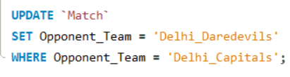

**Outcome:**

All entries in the "Opponent_Team" column will have "Delhi_Capitals" updated to "Delhi_Daredevils," resulting in consistent team naming in the "Match" table.